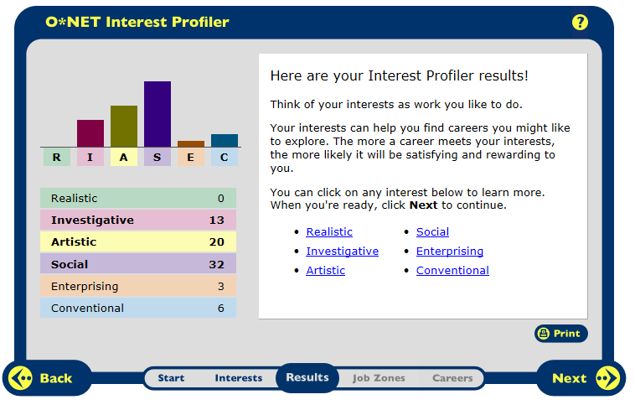
My highest interest category is Social. I agree that this is my strongest interest area because this area is for people that like working with others to help them learn and grow. This aligns with my personal interests. I love to help people and have always volunteered to work with children whenever possible.
My second highest interest category is Artistic. I believe that this is because music is a large part of my life. In and out of school I am involved in music in some way. I am in various music groups and also play piano at home in my spare time.
My third highest interest category is Investigate. I agree with this category because it is very close to social. It is defined to search deeper and think about certain aspects of a topic. This is much like my personality because I like to find as much information about a topic as I possibly can.
Social | Artistic | Investigate
Special Education Teacher | Musician | Speech Pathologist
Occupational Therapist | Interpreter | Audiologist
Childcare Worker
Dietician

Career Research Data for Various occupations
Career Research Questions | Special Education Teacher | Occupational Therapist | Childcare Worker | Dietician
HR 1. Occupation Definition | work with students with disabilities ranging from mental to physical teach severely disabled students basic life skills | treat patients with through therapy about daily activities, through therapy they will improve and recover skills needed for daily life | Care for children whose parents are unavailable, take care of their daily needs such as feeding, as well as prepare them for kindergarten | experts in food and nutrition, advise people to lead a healthy life or reach a specific goal
HR 2. Related Occupation | Audiologist, career and technical education teachers, childcare worker | Athletic Trainers, Physical Therapist, Recreational therapist | Elementary School Teachers, Preschool and Childcare center directors, preschool teachers | Health Educators
HR 3. Compatible Personality | Social | Social | Social | Social
HR 4. Education/ Qualifications needed | Bachelor’s degree and state certification (not needed for private school) | Master’s degree and be licensed | Range from high school diploma to early childhood education certificate | Bachelor’s degree and supervised training
HR 5. Technology Skills needed | Computer skills in order to keep detailed records of student progress, word skills to communicate with parents | Knowledge of different devices to help regain full capacity of their daily life, and up to date records of patient’s daily progress | Basic computer skills in order to communicate with students’ parents | Skills to record research and data of patient’s progress. Knowledge of nutrition applications to create data and analyze food.
RC 1. Median Salary | $53,200 per year | $72,320 per year, $34.77 per hour | $19,300 per year, $9.28 per hour | $53,250 per year, $25.60 per hour
RC 2. Projected Job Growth | 17% Increase | 33% increase | 20% increase | 20% Increase
RC 3. Organizations that hire | Public and Private Schools | Schools, Hospitals, Nursing Homes | home daycares, public and private daycares | laboratory, hospital, private business, schools
ISC 1. Working Conditions | Usually work school day hours, spending some weekend hours preparing. Some choose summers off while others work. Work 1 on 1 or in small groups | Most work full time. Hours vary depending on where working and to accommodate patient schedules. Various facilities and may travel | Full days to accommodate parent schedules. Spend most of day moving around caring for children. Part of day outside to get fresh air with children. | Full-time 6-7 days a week. Some have flexible hours if they are self-employed. Some with individual patients, others with corporations.
ISC 2. Part of a Union? | Yes | Yes (if in public School) | No | Yes (if in hospital)
ISC 3. Opportunity for Advancement | Coordinator or Director based on higher education | Could be supervisor in a larger company | opportunity to become lead teacher or director | supervisor or manager of a larger organization
Universities/ Colleges | Bridgewater, Framingham, or Fitchburg State | Salem State, Worcester State, Springfield College | Anna Maria College, Elms College, Framingham State | UMass Amherst, Boston University, Tufts

Career Research Data for Various occupations
Career Research Questions | Musician | Interpreter | Speech- Pathologist | Audiologist
HR 1. Occupation Definition | play instrument for live audiences and recording studios | convert information from language to another, work in sign language | diagnose and treat swallowing and communication disorders | diagnose and treat hearing and balance problems
HR 2. Related Occupation | actors, dancers and choreographers, high school teachers | adult literacy teachers, career and technical education teachers, court reporters | audiologists, occupational therapist, physical therapist | occupational therapist, optometrist, physical therapist
HR 3. Compatible Personality | Artistic | Artistic | Investigative | Investigative
HR 4. Education/ Qualifications | No formal education requirement. Training varies for job wanted to achieve | Bachelor’s degree and knowledge of another language | Master’s degree and certified by state | Doctoral degree and must be licensed
HR 5. Technology Skills needed | Skills in order to promote their music. Also, skills in order to convert their music to digital files on the computer. | Basic knowledge of data base tools. | Basic technology to document patient progress. Newest speech technology such as speech boards and assistive tech. | Use basic technology to document patient progress. Also medical related tools, newest and updated.
RC 1. Median Salary | $22.39 per hour | $43,300 per year, $20.82 per hour | $66,920 per year, $32.17 per hour | $66,660 per year, $32.05 per hour
RC 2. Projected Job Growth | 10% Increase | 42% Increase | 23% Increase | 37% Increase
RC 3. Organizations that hire | private venues, restaurants, bars, public celebrations | schools, performing arts centers, large public venues, hospitals, doctors offices | Hospitals, private and public schools, nursing homes, early intervention | Hospitals, private and public schools, nursing homes, private business
ISC 1. Working Conditions | Set own hours, book gigs, schedule recording time. Most work nights at some point playing gigs | Hours can vary greatly depending on setting. Work in various locations. Self- employed leaving time periods with no work | Full-time hours. Some work in schools other in hospitals. If contract out, may have to travel to different patients | Full-time, odd hours to accommodate patient’s schedules. Healthcare facilities, some affiliation with schools
ISC 2. Part of a Union? | No | Yes (if hospital, public school) | Yes (if in public school) | No
ISC 3. Opportunity for Advancement | Most are self-employed leaving no room for promotion | Mostly through word-of-mouth receive more jobs from being well-known | Opportunity to specialize in a certain disorder and be recognized by the board | Usually just an advancement in pay, may have chance to become director of a program
Universities/ Colleges | Berklee College of Music, Boston Conservatory, UMass Amherst | BCC, Northeastern University, University of Rochester | Worcester State, Northeastern University, Assumption College | Elms College, Northeastern University, UMass Amherst

